Reference: <https://en.wikipedia.org/wiki/Card_sorting>

Modify the HTML file and create a closed card sort tool. Use the text in the rows as the cards and the text in the column header will be the group/category

Example card sort layout:

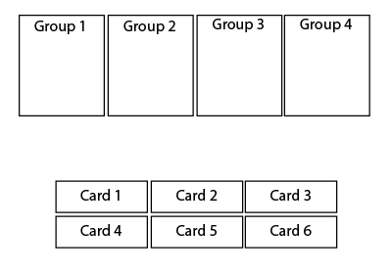

The tool should have the following features:

* All the cards should be visible and are not in a group initially
* Users can drag and drop the cards to only one group
* The cards and the text in the card should be visible and readable when they are dropped in the group
* Group header should always be visible
* The radio button in each row should be selected based on which group the card was dropped
* The next button should only appear once all the cards have been dropped into a group

Additional Features:

* Cross-browser compatible e.g. chrome, Firefox, IE, etc.
* User-friendly design e.g. card & group size, font, font color, background color, etc.
* Responsive design tool fits both desktop, tablet, and smartphone